**Name: Mayur Chandrashekhar Bagul**

**Gender: Male**

**E-mail Address: mayurbagul501@gmail.com**

**Mobile No.: 9930677963**

**Career Objective:** To secure a position which would enhance the skills and to excel the field through hard work,researchand perseverance.

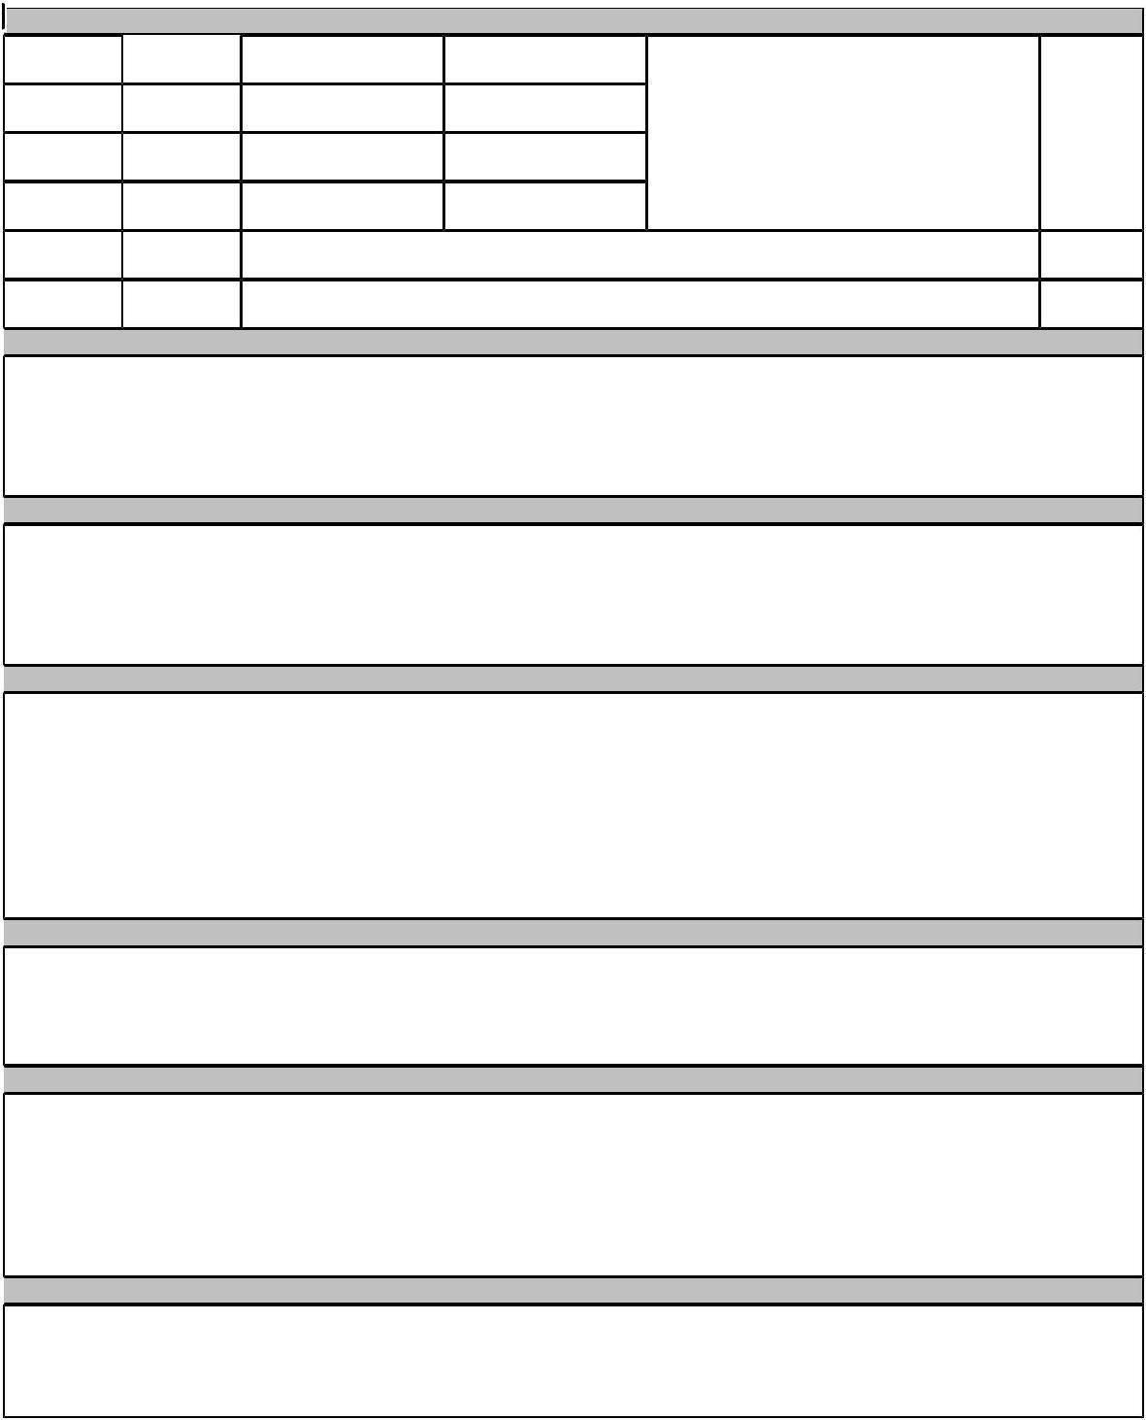

|  |  |  |  |  |  |  |  |  |
| --- | --- | --- | --- | --- | --- | --- | --- | --- |
| **ACADEMIC BACKGROUND** | | | Sem 8 | Sem 7 |  |  |  |  |
| B. E. | May |  |  |  |  |  |
| 2018 |  | 8.65 | 8.21 |  |  |  |  |
|  |  |  |  |  |  |
| T. E. | May | | Sem 6 | Sem 5 | Department of Instrumentation Engineering | |  |  |
| 2017 |  | 8.39 | 7.29 |  |  |  |  |
|  |  |  |  | 7.6 |  |
|  | May | | Sem 4 | Sem 3 |  | **Bharati Vidyapeeth College of Engineering,** |  |
| S. E. |  |  |  |
| 2016 |  | 7.78 | 7.74 |  | **Mumbai University** |  |  |
|  |  |  |  |  |
| F. E. | May | | Sem 2 | Sem 1 |  |  |  |  |
| 2015 |  | 6.48 | 6.15 |  |  |  |  |
|  |  |  |  |  |  |
| Class XII | feb | |  |  | HSC |  | 72.00 |  |
| 2014 |  |  |  |  |  |
|  |  |  |  |  |  |  |  |
| Class X | Mar | |  |  | SSC |  | 86.55 |  |
| 2012 |  |  |  |  |  |
|  |  |  |  |  |  |  |  |

**ACADEMIC ACHIEVEMENTS**

* Won Second prize in bharati vidyapeeth college of engineering for **Technical paper presentation** organized by department of instrumentation engineering.
* Won Frist prize in A.C.Patil college of engineering for **Technical paper presentation** organized by department of electrical engineering.
* Won First Consolation in inter-college **Mini project Competition** for the topic Gas Leak detector in 2016.

**CERTIFICATIONS**

* Certification for Design, Innovation, Creativity and Entrepreneurship Bootcamp in ISME in 2017.
* Certification for workshop and project competiton on IoT in 2017
* Certificates of participation in Intercollegiate Technical quiz competition(Seedling) organised by department of instrumentation Engineering at BVCOE in 2016 and 2017.
* Certification for Solar panel making in 2018

**PROJECTS AND INTERNSHIPS**

* **Mini Project**:**Gas leak detector** : A Project was designed to detect the LPG Gas from 200 parts per million(ppm) to10,000 ppm.whenever there is LPG concentration of 1000 ppm in area the output pin of sensor goes high. Components Used: MQ-2 Gas Sensor,IC-555,Transistors,Battery,LED,Capacitors,Registers,Variable register, Diode, Relay,PCB**.**
* **BE Project**:**Biomedical Waste Management System** : Biomedical waste is any kind of waste containing infectiousmaterials. Bio medical waste is hazardous to the environment. It is not easily decomposed. The Objective is to design a prototype for a biomedical waste management system which can crush waste into small parts. the it sterilize the biomedical waste to make it bacteria free.
* **Industrial Automation (PLC,SCADA,HMI,VFD) training** through LIVEWIRE ISO certified Institution

**POSITION OF RESPONSIBILITY**

* **Joint Sports Secretary** of BVCOE in 2017 and Active Member of **Council Committee** at BVCOE.
* **Head** for the Non-technical events and **Co-Head** for technical paper presentation in inter collegiatetechnical fest INFINITI''17at BVCOE in 2017 and 2018.
* **Volunteered** for inter-college Mini project Competition organized at BVCOE in 2016.

**EXTRA CURRICULAR ACHIEVEMENTS**

* Played through **Mumbai Cricket Association (MCA**) from 2010 to 2012,Played for **District Level Cricket** **Tournament** in 2013 and 2014 and Played for intra college cricket tournament in 2015,2016 ,2017and 2018.
* Secured 1st Position in **Neon Cricket** Competition held in various colleges in 2016 and 2017.
* Successfully Completed Personality Development Camp with 32 different skill sets at **Bhonsala Military** School in 2011.
* Participated **at District Level for Carrom Championship** in 2010 and Participated at **National Level** **for Painting Competition** in 2006.

**ADDITIONAL INFORMATION**

**PreferredProgramming Language:** C

**Hobbies**: Playing Cricket ,Watching South Movies .

**Interests**: Exploring new places ,Trying different cuisines